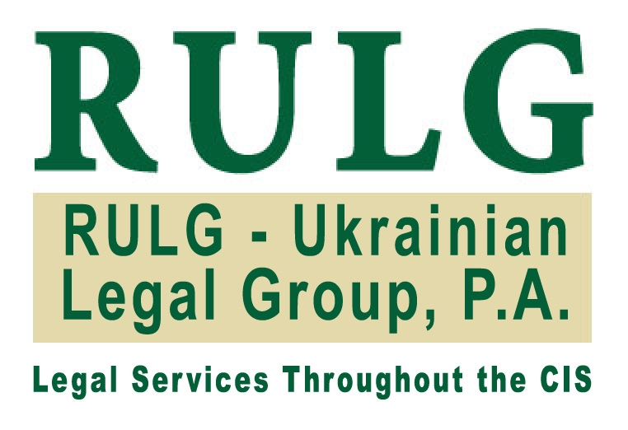

RULG-UKRAINIAN LEGAL GROUP, P.A.

Kiev, Ukraine and Washington, D.C., USA

SECOND CIS LOCAL COUNSEL FORUM
25 – 27 June 2008

Holiday Club Saint Petersburg
St. Petersburg, Russia

Outline of the Presentation

on

Legal Climate for Investing in Ukraine

Legal Climate for Investing in Ukraine

Dr. Irina Paliashvili
President, RULG-Ukrainian Legal Group, P.A.

Washington, D.C. and Kiev
irinap@rulg.com
www.rulg.com

I. Introduction

Over most than 15 years of our corporate and investment practice in Ukraine, we have assisted numerous foreign companies in various industries with their Ukrainian investments, which allows us to summarize the key recommendations with regards to investing in Ukraine.

II. General Remarks

At the outset, we should mention that Ukraine is an important part of the so called “emerging Europe”, its economy has demonstrated steady and sustainable growth for many years, and it offers an attractive and fast-growing market for investors in many industries.

However, in light of the fundamental and systematic economic reforms needed in Ukraine, and of an ongoing sharp increase in foreign and domestic investment, it is imperative to ensure that Ukraine’s legal system is prepared to serve as a modern pillar for the economy and society. The current legal foundation is inadequate and to a large extent, sabotages the development of a market economy in Ukraine. It is archaic, anarchic, and at times absurd.

The problems, which the investment community faces are numerous, but can be broadly classified in the following groups:

- Corporate and commercial laws: the existing company law is outdated, incomprehensive (we still do not have a law on joint-stock companies) and flawed; the Commercial Code is anti-market and is in fundamental conflict with the more market-oriented Civil Code, etc.

- Overregulation: abundance of regulations and a government predisposed to interfere in business affairs has created a system that is chaotic, arbitrary, excessive, and incredibly costly to foreign investors.

- The tax system and multiple tax bureaucracies are complicated, with the worst offenders being the value-added tax (VAT) and unjustifiably high social taxes.

- The currency regime and financial sector need liberalization. Unnecessary obstacles and hidden charges include the overregulation of ordinary financial activities. For example, in order to perform many one-time simple financial activities, National Bank of Ukraine (NBU) has excessive licensing requirements with regard to foreign currency transactions and payments outside Ukraine. The NBU also has draconian international loan requirements, and it constantly interferes with the investment regime, inventing new barriers to investment.

- Anti-monopoly legislation is unnecessarily broad and ambiguous, over-regulating economic concentrations with extremely low thresholds, which in turn forces companies to seek the Antimonopoly Committee of Ukraine’s prior approval of actions that have no bearing on competition in the Ukrainian market at all.

- Another concern is the ongoing moratorium on sale of agricultural land, and restrictions on land ownership by foreign investors.

- Intellectual property: Intellectual property protection is lacking, especially in enforcement.

- Corporate raids: Legislative gaps and conflicts within the legislation, combined with lax ethical standards in Ukraine's bureaucracy and judicial branch make corporate raids an increasingly pressing issue for foreign investors.

All of these problems, although constantly and loudly criticized by the business community, have been neglected by several generations of the country's leadership. No government so far has been willing to develop a strategic program of reforms for the legal and regulatory system, and it remains to be seen whether the current government will make a serious and honest effort to address them.

The market, however, responds to this situation in a healthy way by avoiding the legal and regulatory regime and corrupt judiciary, while ignoring the more absurd laws and concentrating on developing the best modern business practices. Unfortunately, this creates an ever-widening gap between what is written in law, what is understood by those who administer the law (government authorities, regulators, judges), and the business community.

At first, this may seem like a reasonable truce, as it does not interfere with the steady development of Ukraine’s markets. But this solution is not harmless – it encourages non-compliance, greatly increases the risks of doing business, provokes artificial commercial disputes, and fosters such ugly trends as corruption, lack of enforcement, corporate raiders, and lack of corporate governance.

The good news is that the business community has not given up, and demand for reform is reaching critical mass. One of the major market tendencies, which will inevitably result in the modernization of legal and regulatory regimes, is the immense hunger of Ukrainian companies for growth. This is equally true for multi-industry giants, medium-sized companies, and small businesses. All are looking for financing on both the domestic and international markets through initial public offerings (IPOs), mergers & acquisitions, strategic and portfolio investment, issuance of corporate debt instruments, and direct borrowing from domestic and international lenders. They can no longer tolerate the obstacles created by the antiquated legal regime and bureaucracy. Another strong drive for fundamental reforms are the international obligations undertaken by Ukraine are.

Several sporadic positive developments of the last two years, such as the adoption of a modernized version of the Securities and Stock Market Law, the adoption of several progressive laws to promote Ukraine’s World Trade Organization (WTO) accession and the successful accession itself, the adoption of stronger anti-piracy optical media licensing rules, the creation of a regulatory framework for mortgage lending, and liberalization of incorporation procedures, were similarly driven by the business community and international organizations and institutions.

Considering the declared policy of Ukraine to adopt all new legislation in compliance with the EU legislation, and Ukraine’s recent WTO accession, we believe that new progressive laws will have to be adopted. WTO accession is especially important in this respect because Ukraine made a full commitment to most important WTO documents (for example TRIPS in the IP sector), and therefore is now bound by imperative implementation. Ukraine also undertook an observer status for the Government Procurement Agreement (GPA). This means that unlike with EU harmonization efforts, which are not mandatory for Ukraine and are carried out on a unilateral basis, WTO harmonization is mandatory and there is a serious monitoring and enforcement mechanism inside WTO, which will ensure Ukraine’s compliance.

In addition to developing domestic laws, Ukraine has been actively undertaking international obligations with regards to investment regime, and is a member of the Convention on the Settlement of Investment Disputes between States and Nationals of
Other States (ICSID) and has signed a number of bilateral investment treaties (“BIT”) with many states.

2008 will be the pivotal year in terms of the desperately needed reforms and modernization of Ukraine’s legal regime and business climate for two main reasons.
First, the business community no longer wants nor can afford to tolerate obstacles created by the legal chaos and inefficient bureaucracy and second, because the new government will be unable to remain in power while ignoring the business community’s demands.

III. How to Minimize Risk: Recommendation to Investors

One of the biggest practical risks at present is corporate raids, especially that no sector is immune from them. Corporate raids are similar to expropriation (creeping expropriation, nationalization) in a sense of ICSID Convention or bilateral investment treaties, and they often involve assistance from corrupt government or courts, but they are not formally recognized as such, and therefore investor do not enjoy the strong protection provided by international conventions and treaties against expropriation. This makes protection from corporate raids a much more challenging task.

Corporate raids: Barbarians at the gate
What we now call “corporate raidership” has existed in Ukraine for years. It has become more organized and professional in recent years, but this ugly trend emerged almost as soon as Ukraine’s market opened up to international investment. There are a number of reasons why this trend has grown to such a dangerous scale: as already mentioned, our underdeveloped and chaotic legal system, flawed judiciary and vast bureaucracy that is at best indifferent or at worst hostile to international investors – these are usual factors that investors complain about. What is discussed less frequently is the factor of careless behavior by international investors. This factor, unlike the other ones, can be controlled by international investors themselves.

Defending against raiders: keep your (potential) enemies close
In our practice, quite a few abuses of international investors by their business partners or hired executive management could have been avoided, if the investors had made the necessary efforts to prevent the abuses and used protection mechanisms that are indeed available under the law. In essence, I want to focus on how international investors can help themselves in protecting their investments.

It is understandable that an international investor, when entering a new market, is looking for local partners and executive management. By using the word “local”, I do not want to imply at all that dishonest business partners or executives are always local nationals, although statistically this is often the case. We had several instances in our practice when international investors were defrauded by expats, who shrewdly took advantage of the trust vested in them, as well as of the imperfections of Ukrainian law. By “local”, I mean partners or executives of any nationality, who are better acquainted with the local conditions, language, legal system, traditions, etc., and on whom international investors are relying.

Most frequently, international investors suffer abuse from their minority local partners, or hired management. The worst-case scenario is when the dishonest minority partner in a company is also hired as the head of executive management (“General Manager” or “GM”). In this case, the investor has to battle on two fronts: terminating the GM's employment, and expelling him as a partner in the company. Very often, such a dishonest partner/GM uses illegal means, and unless the international investor resorts to similar means (which does not happen often, and which we do not recommend), the battle will be long and costly for the international investor. Sometimes, it can cost more than the investment itself.

In general, there are two formal protection mechanisms that should be looked at: company charter and employment contract with the GM; and one practical mechanism: setting up an internal system of checks and balances, through which the activities of the local partner/GM can be closely monitored and abuses can be prevented. The international investor, even if it does not participate in the day-to-day management of the company, possesses such important tools, provided by the law, as the company’s supreme and supervisory bodies, the possibility to restrict the powers of the GM, the right to review financial and other documents of the company, the right to audit the activities of the company, etc. All these tools should be used to the greatest possible extent through the company charter and employment contract with the GM. And it is really surprising how infrequently international investors are using these tools in practice.

It is important for an investor to take full advantage of external audits by directly hiring truly independent auditors, paying their bills directly and demanding complete and comprehensible reports that flag potential risks where necessary. If such auditors come back and report a lack of cooperation from the GM, this should cause immediate concern, and immediate measures should be taken (hopefully prescribed in the company charter and in the employment contract with the GM) to ensure full cooperation and disclosure on the GM’s part.

Defending against raiders: How to dig an effective moat
Here is a list of common sense and practical “self-help” recommendations for international investors:

- Insofar as you find it possible, comply with the law when setting up and operating your business in Ukraine.

- Focus on monitoring your investment and on preventing abuses. In case of any concern – react immediately.

- Do not make your partner the GM and do not make the GM your partner.

- Actively use the protection mechanisms available in the law and international treaties.

- Set up a practical internal system of checks and balances, and make sure this system is in compliance with Ukrainian law (often global internal corporate rules are unenforceable in Ukraine, and need to be “translated” into local legal language and duly adopted).

- In case of a problem, act swiftly and decisively, but in compliance with the law (e.g. even the most dishonest GM, if dismissed improperly, will be restored to his position by the courts, and often will be awarded damages).

- Avoid any dubious activity and verify any recommendations from local partners/GM if you suspect that what they are suggesting may be illegal (if you bend the rules, you will give them ammunition to blackmail you in the future).

- Avoid the court system. Use every opportunity to negotiate and settle. It may be frustrating and unfair, but in the long run it will save you considerable time and money.

- Watch your investment, learn your lessons and have a very successful business in Ukraine!

